**(Approved by UAC)**



**SAMPLE**



|  |  |  |
| --- | --- | --- |
|  | **UNIVERSITI KUALA LUMPUR** | |
|  | **ASSESSMENT BRIEF** | |
|  |  | |
|  | **COURSE DETAILS** | |
| **CAMPUS** | MALAYSIAN INSTITUTE OF INFORMATION TECHNOLOGY | |
|  |  | |
| **COURSE NAME** | ASP.NET WEB PROGRAMMING | |
|  |  |  |
| **COURSE CODE** | ITD21203 |  |
|  |  | |
| **COURSE LEADER** | HANA MUNIRA MUHD MUKHTAR | |
|  |  | |
|  |  | |
|  | **ASSESSMENT DETAILS** | |
| **TITLE/NAME** | PROJECT |  |
|  |  |  |
| **WEIGHT** | 20% |  |
|  |  |  |
| **REQUIREMENT** |  |  |
|  | 1. ASP.NET | |
|  | a. | Master Page |
|  | b. | User Controls |
|  | c. | Validation Controls |
|  | d. Class & Object (Calculation) | |
|  |  |  |
| **PRESENTATION** | WEEK 13 |  |
|  |  |  |

**(Approved by UAC)**

**QUESTION 1: CINEMA TICKETING**

Create a web form for ADMIN to enter movie information into a database. Also, create a web page that lists all movies that have been entered into the database.

Create a table named **movies**, containing the following fields:

|  |  |
| --- | --- |
| id | INTEGER automatic unique id |
|  |  |
| name | VARCHAR |
|  |  |
| year | YEAR (YYYY four-digit number) |
|  |  |
| genre | INTEGER (see detail below) |
|  |  |
| ticket price | DECIMAL |
|  |  |
| date | DATE |
|  |  |
| time | TIME |
|  |  |

The **genre** should at least contain the following genre names:

* 1 = Action/Adventure
* 2 = Comedy
* 3 = Drama
* 4 = Fantasy/Sci-Fi

Create a web form for USERS to purchase movie tickets. USER information will be stored in a table and they should be able to;

1. key in their name and contact number o view movie information by genre or year

o choose a movie, key in the number of tickets, and view the total price

**(Approved by UAC)**

**QUESTION 2: CAR FOR SALE**

Create a table **carforsale** in your current database.

Create a web form for the CAR MANAGER to insert given information (Refer to Figure 1) in table

**carforsale.**

Create a web page that lists all cars that have been entered into the database. This information should be viewed by the range of **cc** or **price.**

|  |  |  |  |  |  |
| --- | --- | --- | --- | --- | --- |
| carID | manufacturerName |  | modelName | cc | price |
|  |  |  |  |  |  |
| 1 | Perodua |  | Ativa | 1.0 | RM 71, 200 |
|  |  |  |  |  |  |
| 2 | Perodua |  | Aruz | 1.5 | RM 73, 266 |
|  |  |  |  |  |  |
| 3 | Nissan |  | Almera | 1.5 | RM 92, 310 |
|  |  |  |  |  |  |
| 4 | Nissan |  | X-Trail | 2.5 | RM 159, 888 |
|  |  |  |  |  |  |
|  |  | Figure 1: Table carforsale | | |  |

Create a web form for the CAR SALESMAN to enter their sales information, such as;

* Name, address, and telephone number of PURCHASER
* Car details

Create a web page that displays the TOTAL SALES and lists all cars that have been sold by the CAR SALESMAN.

**(Approved by UAC)**

**QUESTION 3: REGISTER A PHP SLOT**

There are 32 students assigned to a module. To organize module demonstrations, the class should be split into four groups with different time slots. Each group should consist of 8 students. The module lecturer decided to have a registration web page to allow students to sign up for one of the demonstrations. A student visiting the page should be able to submit their name, student ID, email address, and book a place in one of the time slots. For example, the registration Web page of PHP slots looks like Figure3 below:

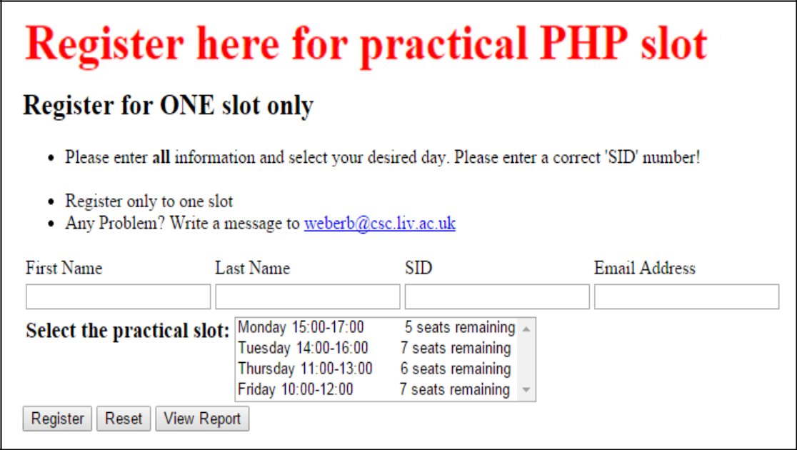

The submitted data should be stored in a database. The page should show how many free places are available in each time slot, announcing and blocking all fully booked time slots. When the **View Report** button is clicked, it should open a separate web page that lists students' information according to the chosen practical slot.